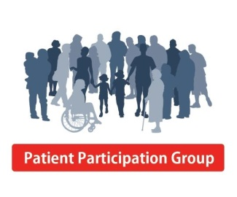

**Charlbury Patient Participation Group Newsletter**

**Issue No.16, June 2022**

**CHARLBURY MEDICAL CENTRE PATIENT PARTICIPATION GROUP**

Welcome to the summer edition of Charlbury Medical Centre patient participation group newsletter.

We all hope that we are now entering a more settled time in primary care, when GP services will return to a pre-pandemic way of working. The long delays in accessing secondary (hospital) care have an impact on GP practices where clinicians find they have to care for patients who are in more pain and are more unwell for longer.

As most of you know, Dr Brookes-White is on a year’s sabbatical from 1 April. Dr Khan will care for some of her patients, others have temporarily transferred to another GP. We welcome Dr Mel Hurney back from maternity leave. In Dr Brookes-White’s absence, Dr McIntyre is the lead clinician in the practice.

**Additional appointments available from 1 October 2022**. In line with “new enhanced access arrangements” required by government, the medical practice is making plans to offer an extra five and a half hours of appointments on weekdays, some before 8am and some after 6:30pm. Each Primary Care Network (ours is Charlbury, Burford, Carterton **Broadhshires** and Bampton) will also have to provide Saturday appointments. We wait to find out how this will be delivered in our PCN. PCNs’ plans will be submitted to the Clinical Commissioners by 31 July and confirmed by 31 August. These additional appointments will be available from 1 October 2022.

**Clinical Pharmacists.** We are now able to consult over the telephone two newly appointed clinical pharmacists: Abigail and Trishna. The clinical pharmacists will carry out medication reviews, discuss adverse reactions to medicines and help with patients’ queries. Patients should contact reception and ask for an appointment with either Abigail or Trishna who will be on call on Tuesday, Wednesday and Thursday.

**Repeat Prescriptions.** A plea from the practice manager Kathy Gale. The slowest, least efficient and most expensive way of ordering a repeat prescription is by ringing the practice. Please whenever possible order a repeat prescription using the NHS App, Patient Access, or putting your slip in the white letter box next to the front door of the practice.

**Social Prescribing.** A new social prescriber, Jennifer, is here to help us connect to all the services, support and activities available locally. Please read her article. Even if social prescribing is not for you, perhaps you know someone who might benefit.

**New Website.** We are pleased to learn that Kathy Gale is working on a new website for Charlbury Medical Centre which she hopes will be up and running by the beginning of next month. We are all agreed that the current website is difficult to navigate and doesn’t provide up to date and useful information in a clear and easily accessible way. We all hope for a much-improved website in the near future.

**More to read:**

* **Lower Back Pain**. The latest advice from the National Institute for Clinical Excellence
* **Red Cross**: Collecting small items of medical equipment in good condition.
* **Social Prescribing**. How can it help?
* **Advice from the Met Office**. How UV affects our eyes, and the increased risk for children
* **Wildflowers in the Grass**. It’s not unkempt!
* **Ambulance calling**. Make sure emergency services can easily see your house name or number

**Lower Back Pain**

**NICE is the National Institute for Health and Care Excellence.** [www.nice.org.uk](http://www.nice.org.uk)

NICE clinical guidelines are recommendations on how doctors and other professionals should care for people with specific conditions. The recommendations are based on the best available evidence.

Clinical guidelines are also important for health service managers and those who commission NHS services.

NICE clinical guidelines can cover any aspect of a condition. This may include recommendations about:

* providing information, education and advice (for example, about self-care)
* prevention.
* treatment in primary care (GPs and other community services)
* treatment in secondary care (provided by or in hospitals)
* treatment in specialised services.

At times they also use consultation with patients to see how the guideline might be useful to them. We thought it would be useful for you to see the older guideline on low back pain, and the very recent one out for consultation on osteoarthritis of the lower limb, in order that you are informed of recent evidence when discussing your condition with your doctor.

**The Lower Back**. The lower back is commonly defined as the area between the bottom of the rib cage and the buttock creases.  Chronic low back pain is tension, soreness and/or stiffness often worsened by movement lasting more than six weeks. Low back pain is a common disorder, affecting around one-third of the UK adult population each year.

NICE’s guideline on low back pain and sciatica recommends exercise in all its forms - for example stretching, strengthening, aerobics or yoga - as the first step in managing the condition.

The guideline also recommends encouraging people to continue with normal activities as far as possible. However, the guideline says massage and manipulation should only be used with exercise because there is not enough evidence to show they are of benefit when used alone.

Acupuncture for treating low back pain is not recommended because evidence shows it is not better than sham treatment. Paracetamol on its own is no longer the first option for managing low back pain. Instead, the guideline recommends that non-steroidal anti-inflammatory drugs (NSAIDs) such as ibuprofen should be tried first.

Combined physical and psychological treatments (talking therapies) are recommended for people who have not seen an improvement in their pain on previous treatments or who have significant psychological and social barriers to recovery.

The updated guideline has been expanded to include people with sciatica, a painful condition typically caused by irritation or compression of the nerves which run from the lower back, through the legs and down to the feet.

Professor Mark Baker, clinical practice director for NICE, said: “Millions of people are affected every year by these often debilitating and distressing conditions. For most their symptoms improve in days or weeks. However, for some, the pain can be distressing and persist for a long time.

“Regrettably there is a lack of convincing evidence of effectiveness for some widely used treatments. For example, acupuncture is no longer recommended for managing low back pain with or without sciatica. This is because there is not enough evidence to show that it is more effective than sham treatment.”

Low back pain causes more disability than any other condition, affecting 1 in 10 people and becoming more common with increasing age.

In the UK it is estimated that low back pain is responsible for 37% of all chronic pain in men and 44% in women and the total cost of low back pain to the UK economy is reckoned to be over £12 billion per year.

**Sciatica** is also a relatively common condition, with estimates suggesting that as many as 40% of people will experience it at some point in their lives.

Professor Baker added: “It is possible to reduce the impact that low back pain and sciatica can have on people’s lives. The guideline continues to recommend a stepped care approach and means people whose pain or function are not improving despite initial treatment should have access to a choice of further therapies.

“Our aim with this guideline is to give clarity and set out the most clinical and cost effective ways to treat low back pain and sciatica based on the best available evidence.”

**Osteoarthrit**is symptoms can be eased with exercise – and can help to improve quality of life, according to new draft guidelines from NICE.

The draft guideline on the care and management of people with the condition recommends that healthcare professionals should encourage exercise and provide evidence-based information to help support their patients. Clinical evidence shows that good outcomes are achievable with tailored exercises, such as muscle strengthening and aerobic exercise, NICE says.

Losing weight can also help to reduce joint pain – the most affected joints are the knees, hips and small hand joints – and NICE says healthcare professionals should support people with osteoarthritis who are overweight.

The draft guideline also recommends osteoarthritis should be diagnosed clinically without the need for imaging (i.e. Xrays and scans) for those over 45, have activity-related joint pain and have either no morning joint-related stiffness or morning stiffness that lasts no longer than 30 minutes. In the absence of evidence of clinical effectiveness or cost effectiveness the committee did not recommend imaging in the management of osteoarthritis, other than as an essential component of preoperative assessment.

Dr Paul Chrisp, director for the Centre for Guidelines at NICE said: “Osteoarthritis can cause people discomfort and prevent them from undertaking some of their normal daily activities. However, there is evidence which shows muscle strengthening and aerobic exercise can have an impact on not just managing the condition, but also providing people with an improved quality of life.

“Beginning that journey can be uncomfortable for some people at first, and they should be supported and provided with enough information to help them to manage their condition over a long period of time.

“Whilst topical and sometimes oral Non-Steroidal Anti-Inflammatory Drugs such as Ibuprofen remain an important treatment option for osteoarthritis, we have taken the decision to not recommend some painkillers, such as paracetamol and some opioids for osteoarthritis.

“This is because new evidence has shown there was little or no benefit to people’s quality of life, pain or psychological distress and particularly in the case of strong opioids, there was evidence that they can cause harm in the longer term, including possible addiction.”

*NICE states:*

*The recommendations in this guideline represent the view of NICE, arrived at after careful consideration of the evidence available. When exercising their judgement, professionals are expected to take this guideline fully into account, alongside the individual needs, preferences and values of their patients or service users. The recommendations in this guideline are not mandatory and the guideline does not override the responsibility of healthcare professionals to make decisions appropriate to the circumstances of the individual patient, in consultation with the patient and/or their carer or guardian.*

*Comment from a CMC patient:*

The difficulty for patients suffering from lower back pain and osteoarthritis wanting to begin exercise as suggested is how to commence exercising safely. They are likely to also be overweight and need suitable instruction and guidance to ‘wake up’ muscles, ligaments and tensions etc. Frequently exercises are provided online or at gyms and injury can occur.

If patients can be supported appropriately, lives can be changed with resolution of lower back pain and patients may not require further support from the NHS.

We would be like to hear from patients suffering from lower back pain, who might be interested in commencing appropriate exercise sessions and we shall investigate if this can be arranged. Patients may also like to speak to the social prescriber Jennifer to arrange a visit to appropriate exercise classes available locally.

**Red Cross Collection**

About that Zimmer frame lurking in the garage ....... the shower stool that you no longer need .... and how about that bed frame device which you used when your relative came to stay...?    If you are no longer using them, it would be good to give them to a relevant organisation, so this may help.

We have organised a collection for the Red Cross of small, non-electrical items, nothing bigger than a wheelchair, on **Tuesday 5th July**, and nearer the time we will let you know where and when to bring your items. As we have no storage space, we are only able to accept them on the morning of the 5th, to be collected by the Red Cross Volunteers from Abingdon on that day. If you are unable to transport them yourselves, we should be able to help.

We hope to have a good collection of unwanted equipment to be able to offer to other patients in Oxfordshire and we are asking you to start considering what items no longer used you are able to donate in preparation for this collection date.

More details will be available on www.charlbury.info including the collection point.   Thank you !

**Social Prescribing in Charlbury Medical Centre**

**“Your doctor isn’t the only person who can help you feel better.”**

Social prescribing is designed to support people with a wide range of social, emotional or practical needs, and can focus on improving mental health and physical well-being. People who could benefit from social prescribing include people with mild or long-term mental health problems, vulnerable groups, people who are socially isolated, and those who frequently attend either primary (GP surgeries, NHS care in the community) or secondary (hospitals) health care.

Social prescribing can involve a variety of activities which are usually provided by voluntary and community organisations. Examples might include arts activities, healthy eating advice and a range of sports and exercise classes.

**A message from Jennifer Dixson- Clegg, our social prescriber.**

**Social Prescribing Link Workers** are alongside you, helping you make the most of opportunities and organisations in the community. Linking with help that already exists in your community is often the most helpful way to improve health and wellbeing, or to find the help you need when changes make life unexpectedly difficult.

Your GP may refer you to a Social Prescribing Link Worker, who is non-medical, or you may wish to contact the Social Prescriber yourself; you don’t need to wait to be referred by your GP. Your Social Prescriber is easy to contact, has time to listen and helps with the things that may be bothering you. Social Prescribing Link Workers work with you - can visit you at home if that’s best - to suggest practical day-to-day solutions for everyday things.

Jennifer Dixon-Clegg is the Social Prescribing Link Worker attached to the Charlbury Medical Centre. Jennifer works with her colleague Emma Fox, another Social Prescribing Link Worker in the Rural West Primary Care Network (PCN). Jennifer and Emma work for Age UK Oxfordshire who provide Social Prescribing Community Link Workers for many GP surgeries in Oxfordshire. As Social Prescribers, Jennifer and Emma work with anyone over the age of 18.

If you would like to speak to Jennifer, please call the Medical Centre Reception and ask for Jennifer’s contact details.

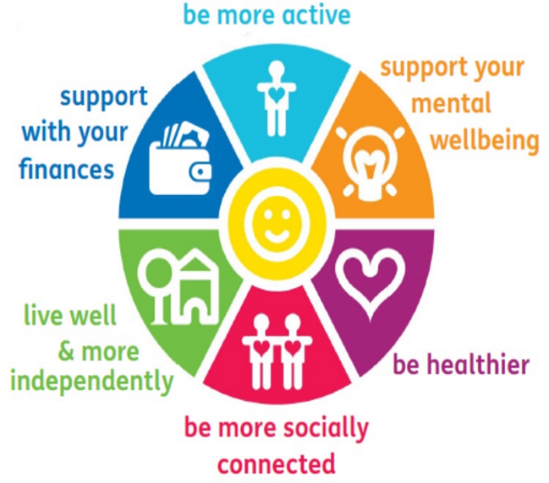**

**Social Prescribing Jennifer**

**Emma**

**Alternatively, call AgeUk on 01235 849 445, email:** [**socialprecribingruralwest@ageukoxfordshire.org.uk**](mailto:socialprecribingruralwest@ageukoxfordshire.org.uk)

# How UV can affect your eyes

You can’t see UV but its damaging effects can stay with you for life. In fact, eyes are 10 times more sensitive to UV than skin.

Most of us are aware that we should protect our skin against UV (ultraviolet) rays by using sun cream and covering up. But do you ever consider what UV can do to our eyes?

Many of us wear sunglasses as a practicality to reduce the glare of the sun, or even to look cool, but there is a more serious reason for wearing shades.

UV radiation from the sun can have both short- and long-term effects on the condition of our eyes. It can burn the surface, cornea and lens of the eye, much like sun can burn skin. Long-term exposure to UV radiation can be serious. For instance, exposure to UV significantly increases the risk of developing cataracts, a clouding of the eyes lens and the leading cause of blindness in the world.

### **UK unaware of health risks**

**According to the Eyecare Trust our eyes are 10 times more sensitive to UV light than our skin but children’s eyes face an even greater risk of UV damage. Big pupils and clearer lenses means that 70 per cent more UV light can reach the retina of a child.**

The World Health Organization estimates that this lack of natural eye protection, combined with the amount of time children spend playing outdoors, could mean that as much as 80 per cent of a lifetime’s UV is absorbed into the eye by the time a child reaches the age of 18.

In the UK, cumulative exposure to UV is one of the main causes of age-related macular degeneration and cataracts – the leading cause of sight loss that affects one in three people aged over 65 years. Parents need to ensure they protect their children’s eyes from the sun, or they are putting them at risk of permanent damage to their sight in the future.

### **Looking after your eyes**

To protect your eyes from UV exposure it is important to wear good quality UV protective sunglasses that block out 99 to 100 percent of both UV-A and UV-B radiation and that screens 75 to 90 percent of visible light. Wraparound sunglasses offer the best protection while grey lenses give proper colour recognition. To protect your eyes further, you should also seek shade during the middle of the day between 11am and 3pm when UV penetration is at its strongest.

The UV index (the strength of the sun) can be high at many times of the year. It is worth remembering that it doesn't have to be hot and the sky doesn’t have to be cloudless for UV levels to be high. We grade the UV level from low to very high, and it is important to take action when UV levels are moderate or above.

<https://www.metoffice.gov.uk/weather/warnings-and-advice/seasonal-advice/health-wellbeing/uv/how-uv-can-affect-your-eyes>

**Wild flowers in the grass**

You may have noticed the wild flowers in the grass at the side of the medical centre. We have left the grass to grow a bit longer and won’t cut it so often to see what wild flowers and grasses emerge. We have also planted some small shrubs and flowers to encourage more insects and birds to visit the site.

We have renewed the lavender bushes growing under the windows of the building and hope they attract many bees and bumble bees.

It will take time to see much difference but every little bit helps to re-dress the devastating loss of habitat nationally and in West Oxfordshire.

Flowers for insects in spring and summer



Wild yarrow



Cowslip

Oxeye daisy

Knapweed



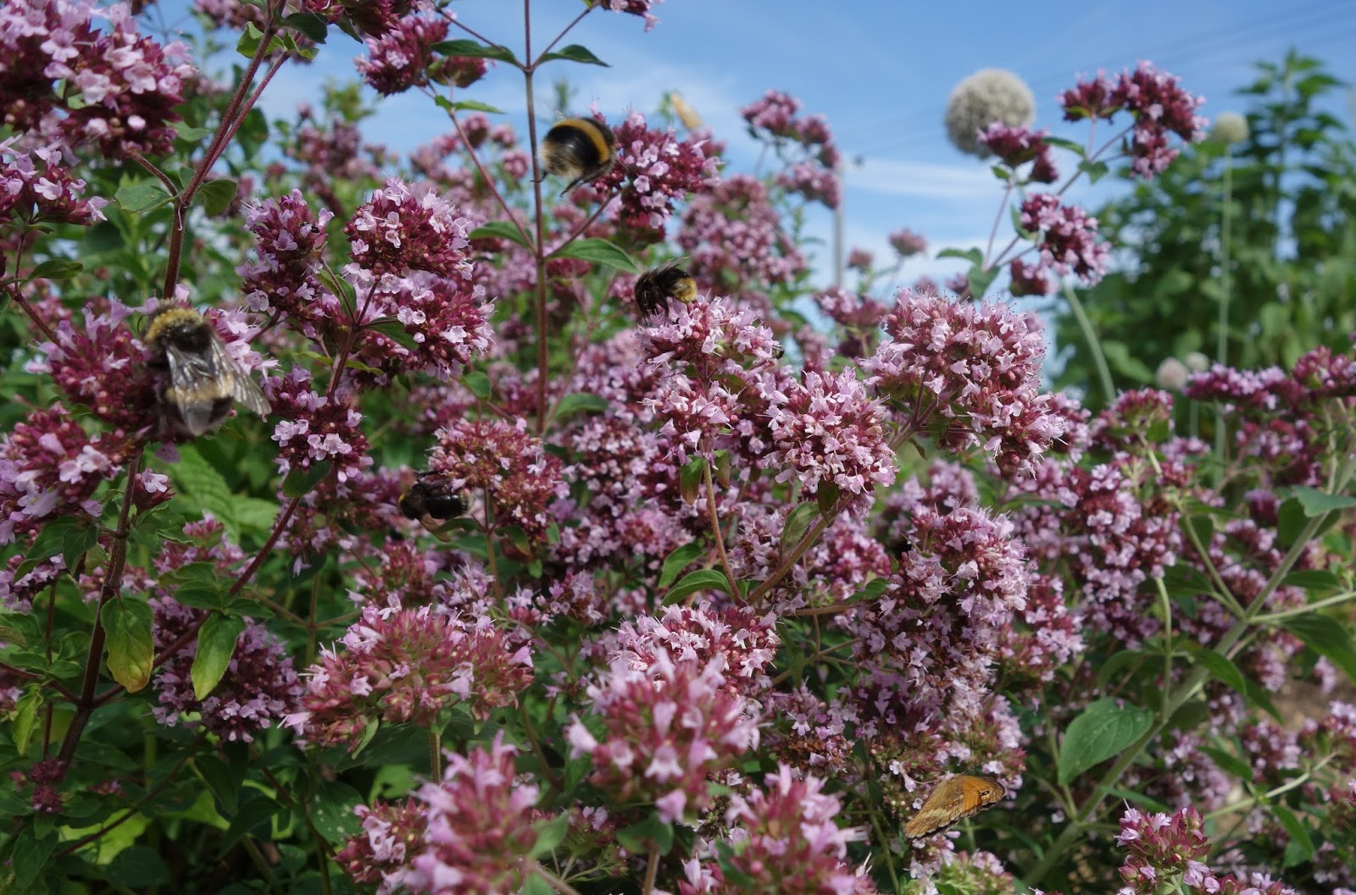

Forget me not

Wild marjoram

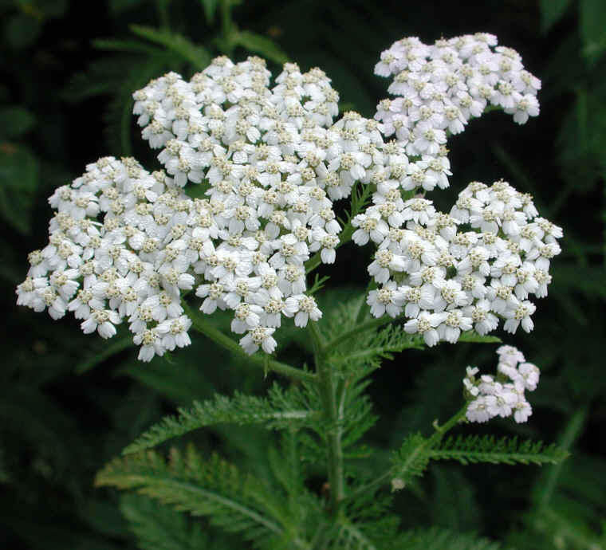

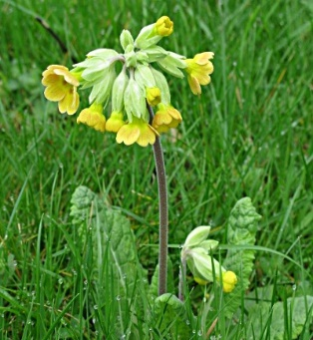

Cowslip

Yarrow

**Pyramidal orchids spotted today in the grass beside the medical centre, 16 June 2022**

Fifteen pyramidal orchid spikes were counted today.   
They take 5-10 years to flower so the plants have been there a long time, just never allowed to flower.



Pyramidal orchids, Anacamptis pyramidalis

This is a widespread and common orchid found on calcareous – chalky - soils. It can vary in colour from a vivid pink, to violet or purple. It is pollinated by a variety of moths and butterflies.



And even more to see:



Fox-and-Cubs, Pilosella aurantiaca

This plant is known for attracting bees, butterflies and moths and other pollinators. It has nectar/pollen rich flowers.

It gets its name because the open flowers (the fox) appear alongside the flower buds (the cubs).

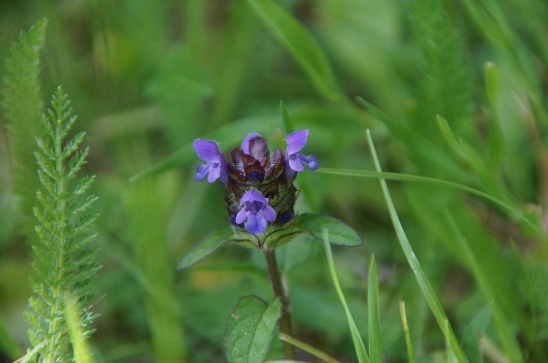

Self-heal, Prunella vulgaris

This little plant stays low to the ground, and attracts bees and butterflies when flowering. It was once a sought-after medicinal herb used by herbalists and used to cure “a variety of ailments”.

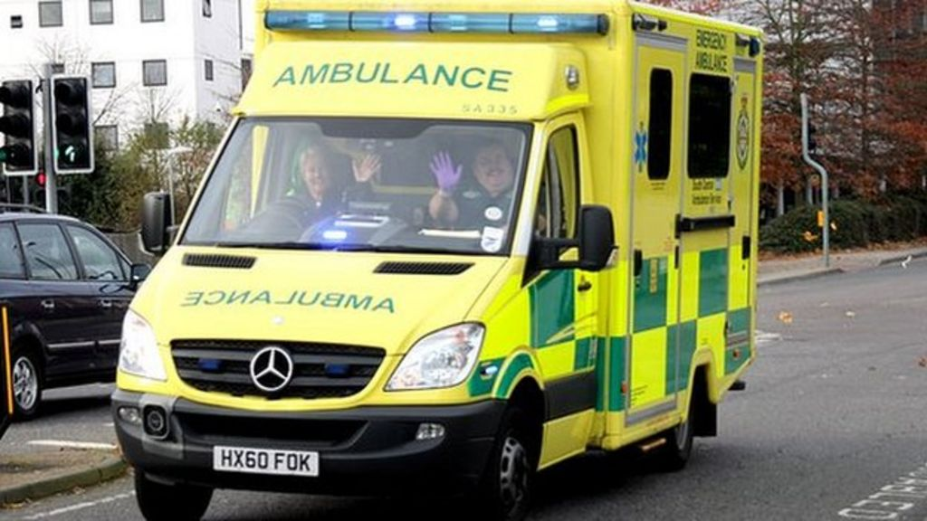 **Ambulance calling!**

**The Ambulance Service, and Out of Hours Service** must be able to seehouse numbers and names clearly especially when visiting for the first time. Not being able to see a name or number from the roadside perhaps because they are obscured by greenery could result in valuable minutes being wasted while trying to locate the house of the caller.

**The Ambulance Service asks that you check that your house sign is visible from the road and makes the following recommendations:**

1. Make sure the sign is not obstructed by trees or greenery
2. If possible, at night switch on outside light if an ambulance or doctor has been called
3. The house name or number should be at least 3inches in height and 4 feet from the ground
4. If the property is more than 75 feet from the roadway, the house number or name should be placed on a box, gate post or wheelie bin, no further than 25 feet from the edge of the street.